## I. Pride

A. Pride is the second of the three of Satan’s deadly sin traps.

B. See that Pride was the _________________________________________________:

1. Pride caused a great fall: Isa 14:12

2. Self focus led to the downfall: Isa 14:13

3. Consider for a moment what the WOG says about your thoughts: Psa 19:14

C. God HATES pride – because it is when man is ______________________________________________: Pro 6:16, Pro_8:13

D. So what does God say is the result of the prideful? The prideful will be destroyed! Pro_16:18, Pro_29:23

E. God labels those who are prideful ____________________: Pro_14:3

F. Men in the Bible who have fallen due to pride:

Sampson - lost his power and then his life due to his pride

Haman – was hanged on his own gallows that he had pridefully made to kill the Mordecai the Jew

Nebuchadnezzar - suffered 7 years of total insanity

Old Testament King Uzziah was generally a good ruler, but he fell through religious pride. He thought he deserved the same privileges as the priests.

King Saul also lost his kingdom after usurping the responsibilities of the priesthood.

The Pharisee in Luke 18:11-13

H. Pride is also the source of fights: Pro_13:10……..If you argue a lot, you are probably VERY prideful!

I. Unfortunately, There are even going to be prideful people in heaven! Luke 14:7

J. God says you must _______________________________ against pride: Pro_11:2

## II. Sexual Immorality

E. What God says in Proverbs about sexual immorality - Pro chapter 5.

1. _______________________________________ is simple. If you have the need – get married! [1 Cor 7:2](https://www.kingjamesbibleonline.org/1-Corinthians-7-2/)-5

2. We must maintain ___________________________________________.

**Notice that Proverbs 5 said that we are to be both ____________ and ______________.**

**And we will be accountable for how we loved our spouse at the Judgment seat of Christ. Eph 5:28 & 33**

**Focus on the family says that Women are suspect to affairs to satisfy their longing for love, appreciation and tenderness. (Men must love their wives)**

**We men mess up because we are so task focused and success focused, that we are not very good at intentionally spending time on our marriage.**

**Focus on the Family also said - Men tend to turn to extramarital affairs to build up their self-image or sexual self-esteem.**

**_____ __________________ _________________**

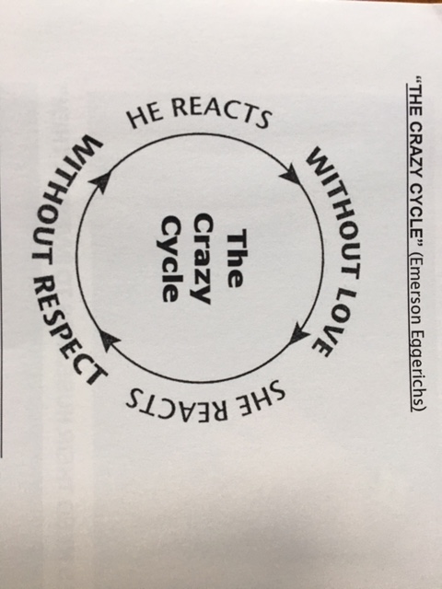

3. Determine that you will honor God and _________________________________________. Pro 5, 6, & 7, 1 Cor 6:18

4. Guard _________________________________________________________: **Mar 7:17-23**

F. Warning signs adultery is present, or coming soon –

1. One partner stops kissing the other with passion. This is one of the biggest signs that adultery is likely – one partner is physically there but no longer emotionally invested.
2. One partner starts to talk about another person of the opposite sex more often that is normal for them – work partner, ministry member, etc.
3. One partner suddenly has work requirements at unusual times – late evenings, weekend times.
4. Partner avoids eye contact with you.
5. Partner makes excuses for not spending time alone with you.
6. Partner no longer talks about emotional feelings – just day to day facts.
7. Partner acts unusually guilty when you do something nice for him/her.
8. Partner quits complimenting you on your physical attractiveness.
9. Partner stops saying, "I love you" and even acts rudely to you.
10. Partner starts buying you gifts to ease his or her guilt.
11. Partner suddenly becomes more preoccupied with appearance.
12. Partner’s Car is suddenly cleaner than usual – kids toys and personal items hidden.

## III. Pornography

A. The entire world, including many here at Midtown church are infested with the sin of pornography: Matt 5:28

**Married? Pornography use is _______________. Not married? Pornography use is _______________**

C. How to Escape Porn:

1. Be a man (or woman) and ___________________________________________ and must get out!

2. Confess your sin to God ([1 John 1:9](http://biblia.com/bible/esv/1%20John%201.9)). And Ask God to cleanse, renew, and transform your mind ([Romans 12:2](http://biblia.com/bible/esv/Romans%2012.2)).

3. Ask God to fill your mind with the things from Php 4:8

4. _________________________________________________ from a Christian friend, including full monitoring on all electronic devices.

## Homework – Points of Application

**Pride:**

Evaluate what you think about yourself –

* + - * 1. Are you always telling yourself how great you are?
        2. Or are you telling yourself that you deserve more?
        3. Or just as bad (and prideful) do you have a woe is me – I don’t deserve this attitude?
        4. Do you find yourself saying prideful things?
        5. Do you find yourself doing or purchasing things with an attitude to impress others?
        6. Do you find yourself admiring prideful people?

What is your plan to correct this wrong thinking?

**Sexual Impurity:**

**If Single;**

* 1. Commit to God that you will remain sexually pure in thoughts and actions.
  2. Identify your area(s) of weakness where Satan is attacking or is likely to attack.
  3. Determine ways that you can protect yourself from sexual impurity.
  4. If tempted, determine ways that you can safeguard yourself from porn.
  5. If using porn, even occasionally, repent and then establish an accountability partner.

**If Married;**

1. Commit to God that you will remain sexually pure in thoughts and actions in your marriage.
2. Discuss your area(s) of weakness where Satan is likely to attack your relationship and discuss it with your spouse.
3. Read Song of Solomon together and note how each partner treats and relates to the other. Determine ways to copy their behavior and have a correct attitude toward both marriage and intimacy.
4. Assure protected times to spend time with your spouse; to build the relationship, and times for your intimate relationship.
5. If tempted, formulate ways that you can safeguard yourself(s) from porn.
6. If using porn, even occasionally, repent and then establish an accountability partner.